

Advanced Photon Source Upgrade Project

Benchmarking vacuum system simulations in SynRad and MolFlow+

Draft

[February 12, 2016]

Document Number: __________________  
ICMS Content ID: APSU_1688669

Version Control

This printed or electronic version of the document may not be the current or approved revision. The current revision is maintained in the Advanced Photon Source Upgrade (APS-U) Project’s Integrated Content Management System (ICMS) where all internal Project document approvals are managed. ICMS can be accessed through the web by authorized users, <https://icmsdocs.aps.anl.gov/>, and this document can be identified by the document and version number as indicated in the Version Control Table below. Note that the version number in the table below and in ICMS may not match. The current approved version is always available in ICMS. Contact the Responsible Person listed below if you are not able to locate the controlled version or access ICMS.

|  |  |  |  |
| --- | --- | --- | --- |
| DOCUMENT No. | WBS No. | REVISION No. | ICMS CONTENT ID |
|  | U.2.2.1.1.4 | 0 | APSU_1688669 |

Approvals for this document will be required from:

Jason Carter – Author, Mechanical Engineer AES-MED Group

Ben Stillwell – APS-U Storage Ring Vacuum System Design Group Leader  
 Mechanical Engineer, AES-MED Group

###### Version Control Log

|  |  |  |  |  |
| --- | --- | --- | --- | --- |
| Document Number | Revision | Responsible Person | Version Date | Description of Change |
|  |  |  |  |  |
|  |  |  |  |  |
|  |  |  |  |  |

Table of Contents

Version Control ii

Table of Contents iii

List of Figures v

List of Tables vii

Acronyms and Abbreviations vii

1. Benchmarking vacuum system simulations in SynRad and MolFlow+ 1

2. MolFlow+ 1

2.1. Benchmarking to theory 1

2.2. Benchmarking to vacuum systems 5

2.2.1. APS-U storage ring vacuum system sector mockup 5

2.3. Benchmarking to comparable programs 5

2.3.1. COMSOL 6

3. SynRad 9

3.1. Benchmarking to theory 9

3.2. Benchmarking to vacuum systems 12

3.3. Benchmarking to comparable programs 13

3.3.1. SynRad3D (Cornell) 13

4. Coupled Simulations 17

4.1. Benchmarking to theory 17

4.1.1. VacCalc 17

4.2. Benchmarking to vacuum systems 19

4.2.1. APS storage ring vacuum system 19

4.2.2. PAR Vacuum System 25

4.2.3. Aluminum PSD study 29

References 37

List of Figures

Figure 2.1.1 Boundary conditions for MolFlow+ tube model 2

Figure 2.1.2 MolFlow+ N2 simulation of tube model with pressure measured along the center of the tube (green lines represent random test particles in Monte-Carlo process) 3

Figure 2.1.3 MolFlow+ N2 pressures compared to theory 3

Figure 2.1.4 MolFlow+ N2 pressures compared for various gas species 4

Figure 2.1.5 MolFlow+ N2 pressures compared for various pipe lengths (centimeters) 4

Figure 2.3.1 Model problem in COMSOL with pumping locations noted 6

Figure 2.3.2 Pressure gradient in COMSOL using the Molecular Flow module 7

Figure 2.3.3 Model problem in MolFlow+ 8

Figure 2.3.4 Comparison of pressure profiles between MolFlow+, COMSOL, and benchmarking data supplied by COMSOL 9

Figure 3.1.1 SynRad model of 0.6 T dipole source projected onto a normal incidence target 10

Figure 3.1.2: Zoom-in to SynRad power density profile 11

Figure 3.1.3 Peak power density profile along vertical stripe of beam 11

Figure 3.3.1 SynRad (CERN) model of first multiplet region of MBA lattice 13

Figure 3.3.2 Al2O3 reflectivity vs photon energy and angle from LBNL Center for X-Ray Optics 14

Figure 3.3.3 Comparison of distribution of photon flux along the length of chamber walls 15

Figure 3.3.4 Comparison of azimuthal distribution of photon flux on chamber walls 16

Figure 4.1.1 VACCALC pressures for the APS-U storage ring at 1000 A*hrs. conditioning (with Foerster aluminum PSD yields) 17

Figure 4.1.2 MolFlow+ pressures for the APS-U storage ring at 1000 A*hrs. conditioning (with Foerster aluminum PSD yields) 17

Figure 4.2.1 APS storage ring ray trace in AutoCAD (APS Dwg. #310308-920016) 19

Figure 4.2.2 Solidworks model for SynRad/MolFlow+ of one sector of the APS storage ring 20

Figure 4.2.3 Heat load distribution in SynRad model of APS storage ring with pumping speeds and total heat loads noted at major absorbers 21

Figure 4.2.4 SynRad flux density distribution (photons/cm2/s, log scale) on vacuum surfaces within model of an APS storage ring sector 22

Figure 4.2.5 MolFlow+ model of APS storage ring sector with pumping surfaces highlighted in red 23

Figure 4.2.6 MolFlow+ pressure profile for one sector of the APS storage ring at 10 A*hrs conditioning 24

Figure 4.2.7 CAD layout of the PAR vacuum system (APS Dwg. #25030101-121000) 25

Figure 4.2.8 SolidWorks CAD model for SynRad/MolFlow+ of the PAR vacuum system 25

Figure 4.2.9 SynRad flux density distribution (photons/cm2/s, log scale) for PAR vacuum model 26

Figure 4.2.10 MolFlow+ model of PAR vacuum system (pumping surfaces highlighted in red) 26

Figure 4.2.11 MolFlow+ pressure profile for PAR vacuum system 27

Figure 4.2.12 Comparison of three of the four aluminum chamber cross sections with published PSD measurements 29

Figure 4.2.13 Comparison of four published H2 PSD yields measured on various aluminum chambers 30

Figure 4.2.14 Cleanup slopes approximated from PSD measurement data 31

Figure 4.2.15 Typical ray trace for design of a laboratory PSD measurement 31

Figure 4.2.16 CAD models of the four chamber geometries for use in MolFlow+ 32

Figure 4.2.17 Ray trace from a PSD measurement recreated in SynRad with photon scattering 32

Figure 4.2.18 Photon flux densities (photons/cm2/s) in log scale determined from SynRad simulations for the four aluminum chamber geometries 33

Figure 4.2.19 Diagram of iterative process for calibrating PSD yields for use in MolFlow+ where the approximated PSD functions are used to map the fluxes from Figure 4.2.18 to outgassing in MolFlow+. The functions are adjusted until the predicted outgassing matches the original data 33

Figure 4.2.20 Comparison of total pressures computed using VACCALC 35

Figure 4.2.21 Comparison of total pressures computing using MolFlow+ 35

List of Tables

Table 2.1.1 MolFlow+ N2 conductance compared to theory for various 2.2cm ID tube lengths 5

Table 2.1.2 MolFlow+ conductance compared to theory for various gases 10 cm length, 2.2cm ID tube 5

Table 3.1.1 Source parameters 12

Table 3.1.2 Comparison of SynRad vs theory 12

Table 4.2.1 Comparison of heat load distributions between SynRad and Ray Trace 21

Table 4.2.2 Comparison of published PSD measurements on aluminum vacuum chambers sorted by surface area of chamber 28

Table 4.2.3 Comparison of relevant experimental factors for various PSD measurements (sorted by numbering from Table 4.2.2) 28

Table 4.2.4 Average total pressures computed using VACCALC and MolFlow+ (sorted from smallest to largest chamber surface area) 34

Acronyms and Abbreviations

|  |  |
| --- | --- |
| APS | Advanced Photon Source |
| APS-U | Advanced Photon Source Upgrade |
| CERN | European Center for Nuclear Research |
| OFHC copper | Oxygen-free high carbon copper |
| PSD | Photon Stimulated Desorption |
| UHV | Ultra-High Vacuum |
|  |  |
|  |  |
|  |  |
|  |  |
|  |  |
|  |  |
|  |  |
|  |  |
|  |  |
|  |  |

# Benchmarking vacuum system simulations in SynRad and MolFlow+

TBD

# MolFlow+

MolFlow+ is a program developed at CERN [1] which generates Monte-Carlo simulations of vacuum systems models within the molecular flow regime and can be used for calculating accelerator vacuum system pressures. The following sections present examples of MolFlow+ being benchmarked to theory, physical systems, and comparable programs.

## Benchmarking to theory

A vacuum model of a tube is created to verify the conductance determined by MolFlow+ for simple geometries. The tube has a diameter of 2.2 cm with 1 mbar*L/s outgassing on one end and 1 L/s pumping on the opposite end, see Figure 2.1.1. Theory [???] says that a tube of length L (cm) and diameter D (cm) will have a nitrogen conductance of:

$C_{N2}=12.3*\frac{D^{3}}{L}$ (Eq. 2.1.1)

The conductance for other gas species can be calculated using:

$C_{gas}=C_{N_{2}}*{\left(\frac{m_{N_{2}}}{m_{gas}}\right)}^{\frac{1}{2}}$ (Eq. 2.1.2)

In order to calculate the conductance of a MolFlow+ model the pressure will be measured along a transparent central facet, see Figure 2.1.2. The pressure at the pumping end is equal to the ratio of Q, the outgassing source, over S, the pumping speed:

$P_{pump}=\frac{Q}{S}\sim 1$ (Eq. 2.1.3)

The pressure near the outgassing source will be defined by Seff, the effective pumping speed:

$P_{end}=\frac{Q}{S_{eff}}=\frac{1}{S_{eff}}$ (Eq. 2.1.4)

Where the effective pumping speed is limited by the conductance C:

$S_{eff}={\left(S^{-1}+C^{-1}\right)}^{-1}={\left(1+C^{-1}\right)}^{-1}$ (Eq. 2.1.5)

Thus in MolFlow+ the pressure will be measured at the gas source end of the tube and the conductance can be calculated using:

$C={\left(P_{end}-1\right)}^{-1}$ (Eq. 2.1.6)

A study was created to compare the results for a tube lengths ranging from 1, 10, 100, and 1000 cms and for 4 common vacuum gases with a variety of molecular weights: hydrogen, methane, nitrogen, and carbon dioxide. The results of this study are shown in Figure 2.1.3, Figure 2.1.4, and Figure 2.1.5 as well as in Table 2.1.1 and Table 2.1.2.

Figure 2.1.3 compares the theoretical and MolFlow+ pressure profiles along a 10 cm length tube. The pressure are nearly equal but the pressure drop for the MolFlow+ model is 15% higher than theory. Figure 2.1.4 compares the results for different gases within an equal length tube. The highest conductance for hydrogen leads to the lowest pressure drop where the lowest conductance for carbon dioxide leads to the highest pressure drop. Figure 2.1.5 compares the nitrogen pressure drop for various lengths of tube with equal diameter.

Table 2.1.1 compares the MolFlow+ calculated conductance to theory for a range of tube lengths. The MolFlow+ conductance becomes more accurate with increased pipe length. Table 2.1.2 compares the MolFlow+ calculated conductance to theory for four gases types. The error is nearly equal for all four gases.

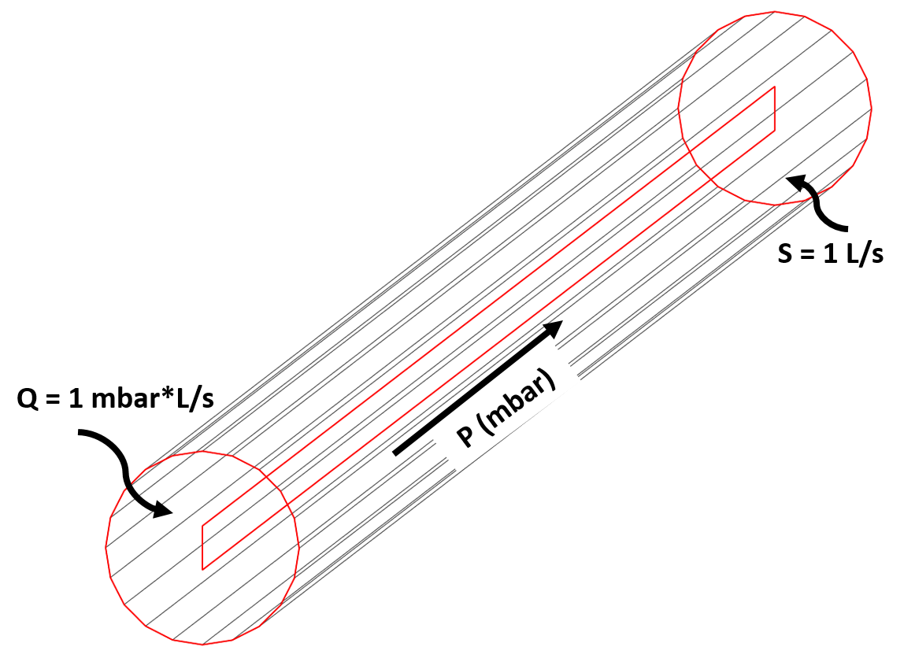

Figure 2.1.1 Boundary conditions for MolFlow+ tube model

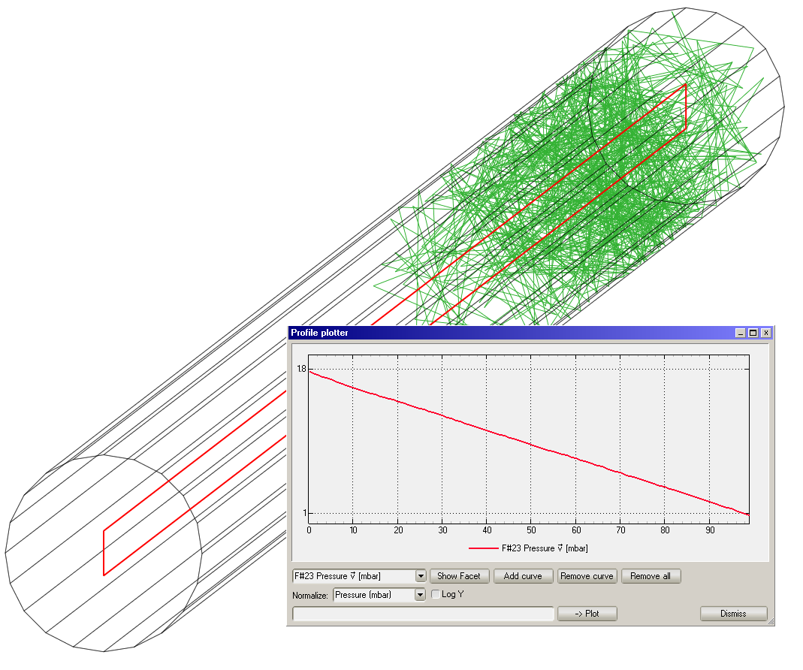

Figure 2.1.2 MolFlow+ N2 simulation of tube model with pressure measured along the center of the tube  
(green lines represent random test particles in Monte-Carlo process)

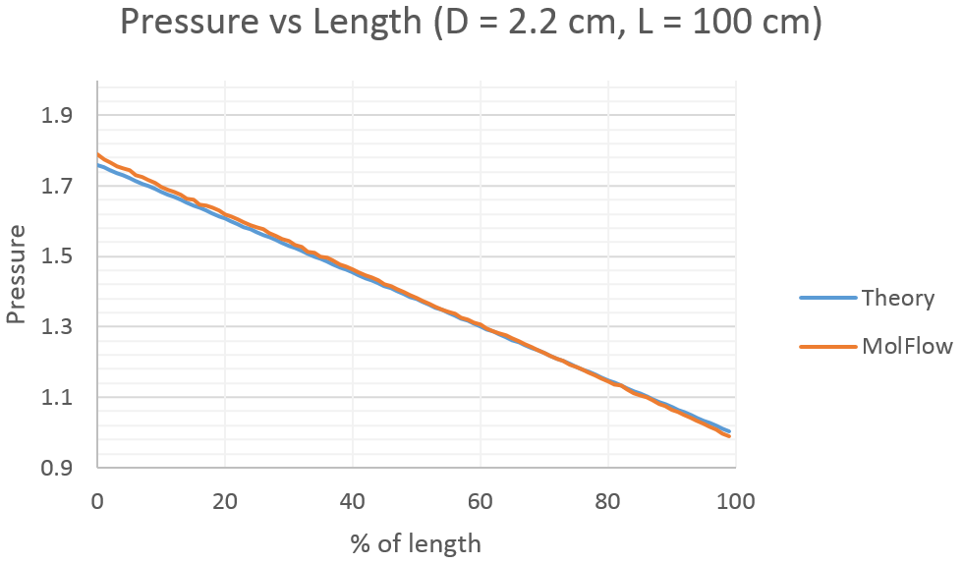

Figure 2.1.3 MolFlow+ N2 pressures compared to theory

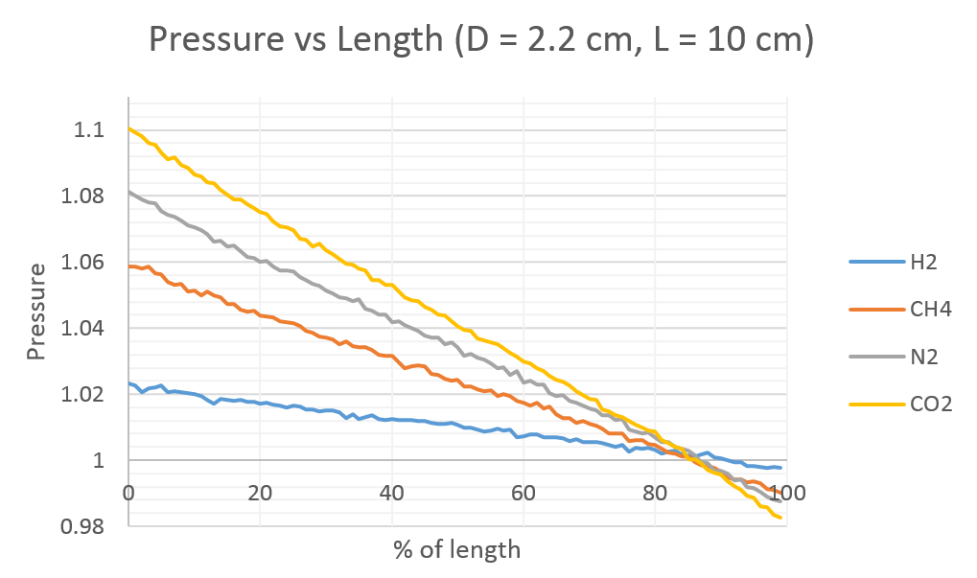

Figure 2.1.4 MolFlow+ N2 pressures compared for various gas species

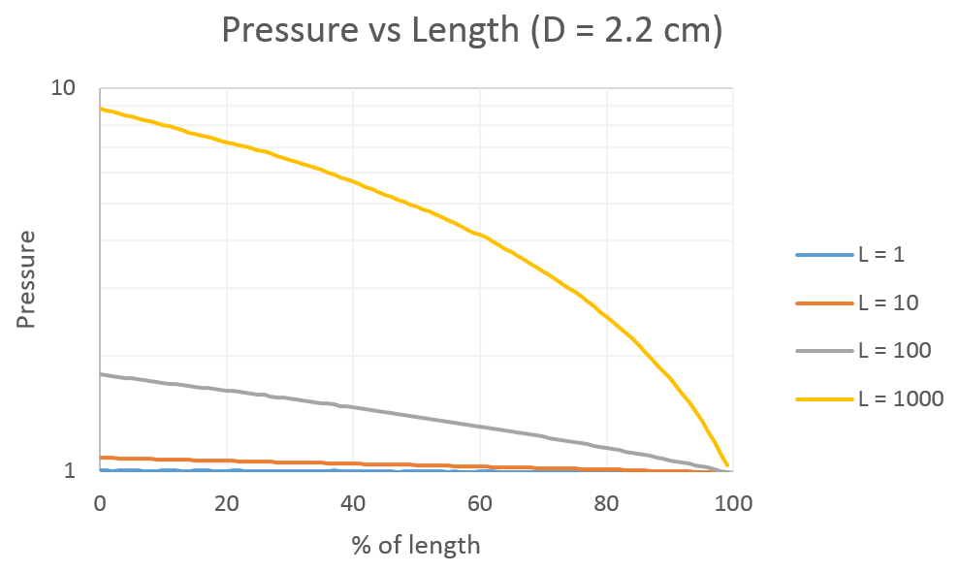

Figure 2.1.5 MolFlow+ N2 pressures compared for various pipe lengths (centimeters)

|  |  |  |  |
| --- | --- | --- | --- |
| Length (cm) | CN2 (L/s) Theory | CN2 (L/s) MolFlow+ | % diff |
| 1 | 131 | 735 | 461% |
| 10 | 13.1 | 12.3 | -6.0% |
| 100 | 0.131 | 0.127 | -3.3% |
| 1000 | 0.0131 | 0.0128 | -2.5% |

Table 2.1.1 MolFlow+ N2 conductance compared to theory for various 2.2cm ID tube lengths

|  |  |  |  |
| --- | --- | --- | --- |
| Gas SPECIES | Cgas (L/s) Theory | Cgas (L/s) MolFlow+ | % diff |
| H2 | 49.0 | 42.8 | -12.6% |
| CH4 | 17.3 | 17.0 | -1.8% |
| N2 | 13.1 | 12.3 | -6.0% |
| CO2 | 10.4 | 9.9 | -4.9% |

Table 2.1.2 MolFlow+ conductance compared to theory for various gases  
10 cm length, 2.2cm ID tube

## Benchmarking to vacuum systems

TBD

### APS-U storage ring vacuum system sector mockup

A mockup of one sector of the APS-U storage ring is being built with completion and operation planned for the fall of 2016. Measurements of the static, ‘no-beam’ pressures of the vacuum system will be taken to verify inputs and assumptions of the MolFlow+ program. Pressure results from a MolFlow+ model of the sector’s vacuum system will be compared to measurements.

## Benchmarking to comparable programs

TBD

### COMSOL

The popular Multiphysics program COMSOL [?] has a Molecular Flow module which can be compared to MolFlow+. The module includes a prebuilt benchmarking model to compare the results for simple thermal outgassing in a pipe model with pumping. The benchmarking model includes a comparison of COMSOL’s results to results using Howell’s 1D Conductance method and a result using Kersevan’s 3D Monte Carlo method which is assumed to be MolFlow+. The problem is that the initial result using MolFlow+ is very noisy and indicates they hadn’t ran the model for any significant amount of time so this model is recreated and reran. The geometry for the new MolFlow+ model was exported directly from COMSOL as an STL into MolFlow. Equivalent pumping of 30 L/s at 2x locations (see ) and 3E-12 Torr*L/s/cm2 outgassing on all non-pumping surfaces.

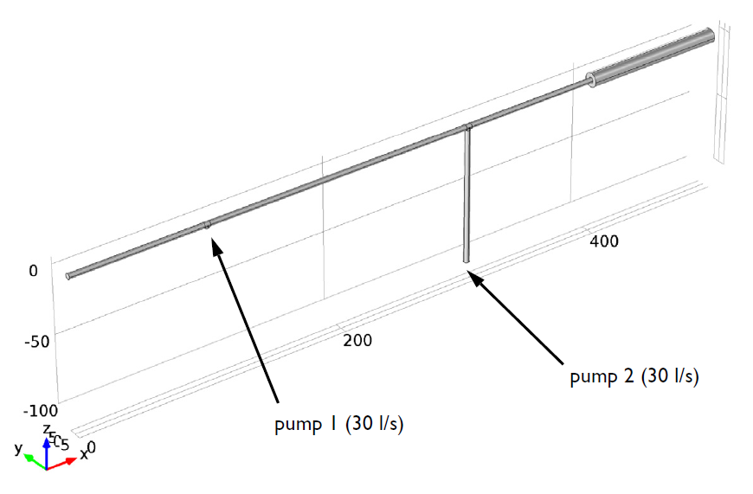

Figure 2.3.1 Model problem in COMSOL with pumping locations noted

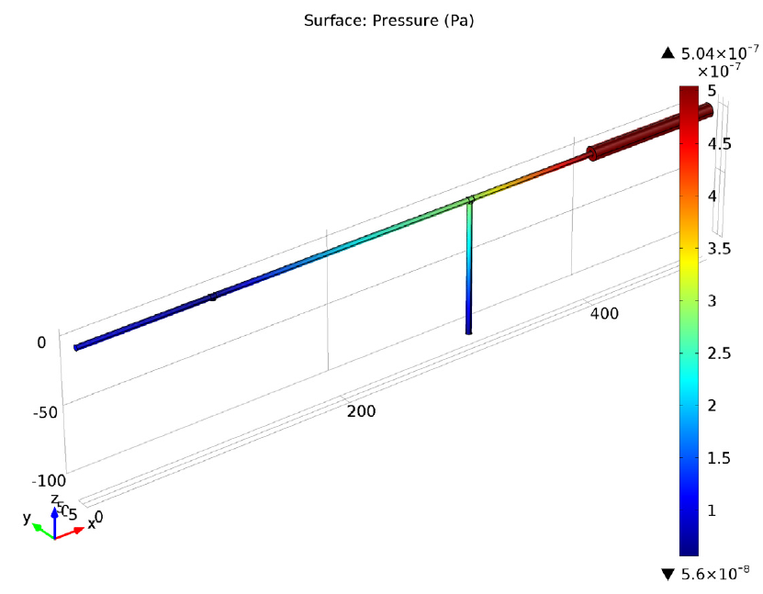

Figure 2.3.2 Pressure gradient in COMSOL using the Molecular Flow module

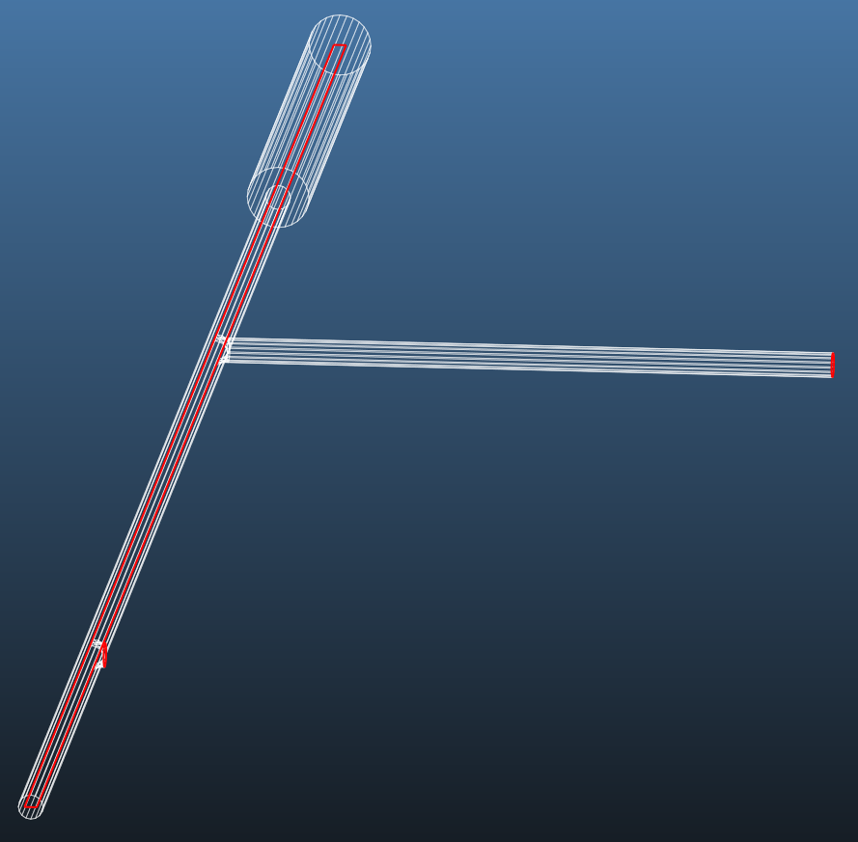

Figure 2.3.3 Model problem in MolFlow+

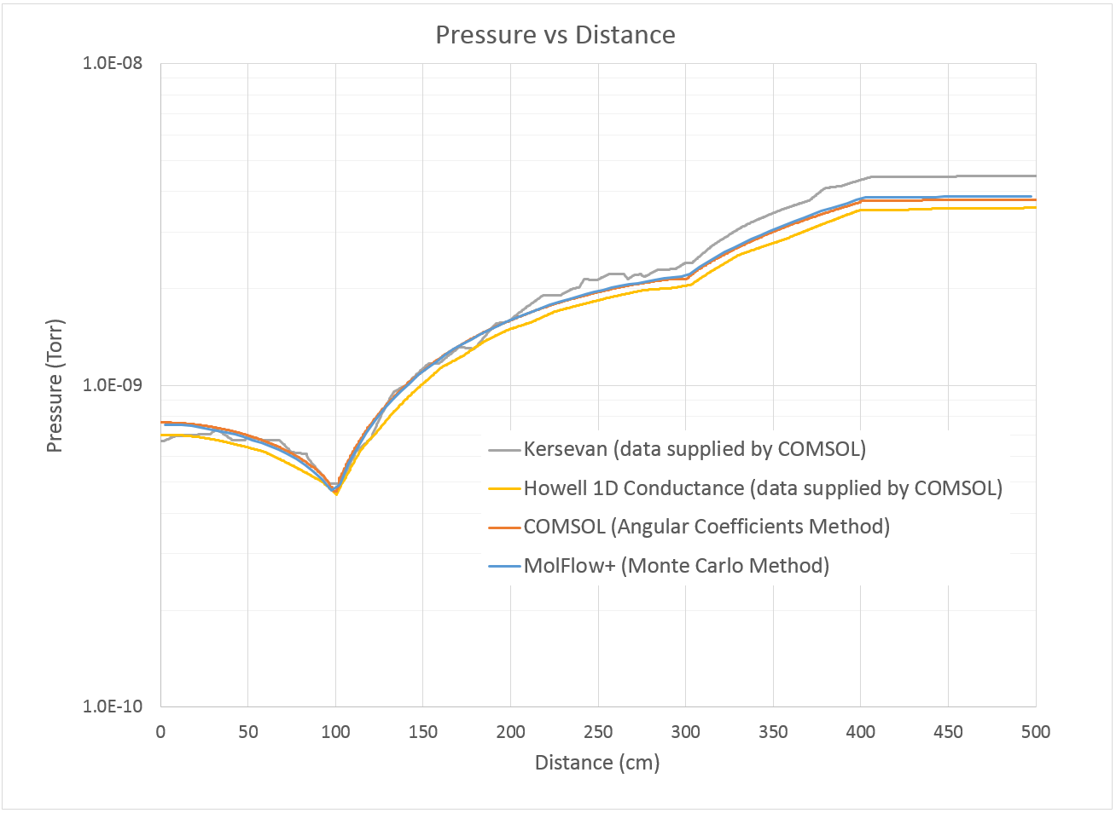

Figure 2.3.4 Comparison of pressure profiles between MolFlow+, COMSOL, and benchmarking data supplied by COMSOL

# SynRad

SynRad is a program developed at CERN [1] which generates Monte-Carlo simulations of synchrotron radiation distributions within models of accelerator vacuum systems. The following sections present examples of SynRad being benchmarked to theory, physical systems, and comparable programs.

## Benchmarking to theory

TBD

$γ=\frac{E_{e}}{mc^{2}}=1957*E\left(GeV\right)=1957*7 GeV=13700$ (Eq. 3.1.1)

Where E is the storage ring energy in GeV.

$E_{c}\left(keV\right)=0.665*B\left(T\right)*E^{2}\left(GeV\right)=0.665*0.6*7^{2}=19.6 keV$ (Eq. 3.1.2)

Where Ec is the critical energy in keV and B is the dipole magnetic field strength in Tesla.

Figure 3.1.1 shows the SynRad model of the dipole radiation projecting onto a downstream target. Radiation ‘lines’ from the Monte-Carlo simulation are shown in green. Table 3.1.1 shows the parameters defining the storage ring and dipole source. Figure 3.1.2 provides a zoom into the power density calculated on the meshed downstream target. Figure 3.1.3 shows a vertical power profile from the downstream target computed at the peak point of power density. The power profile captures the Gaussian shape expected from the synchrotron radiation fan and is compared to a theoretical power profile. The SynRad power profile is slightly wider than the theoretical dipole with a slightly lower peak power density. The total power generated from the SynRad dipole is 670 W and the peak power density is 1773 W/cm2. Table 3.1.2 compares the SynRad results to the theoretical dipole output. The total power generated matches near identically. The peak power density for SynRad is lower by 3%.

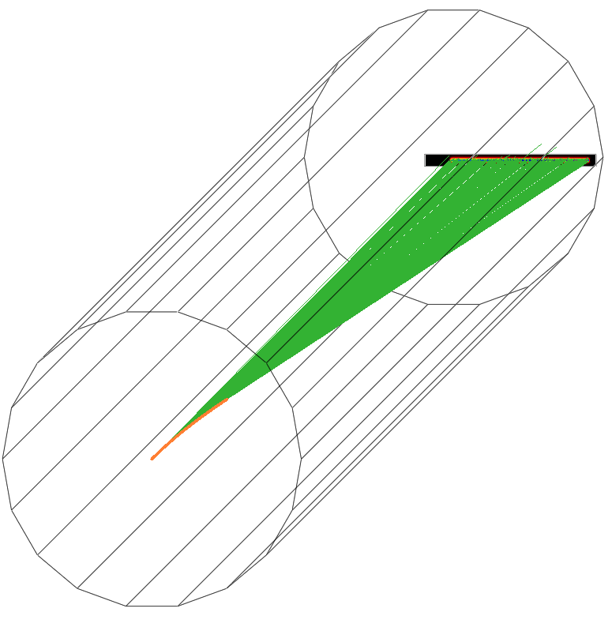

Figure 3.1.1 SynRad model of 0.6 T dipole source projected onto a normal incidence target

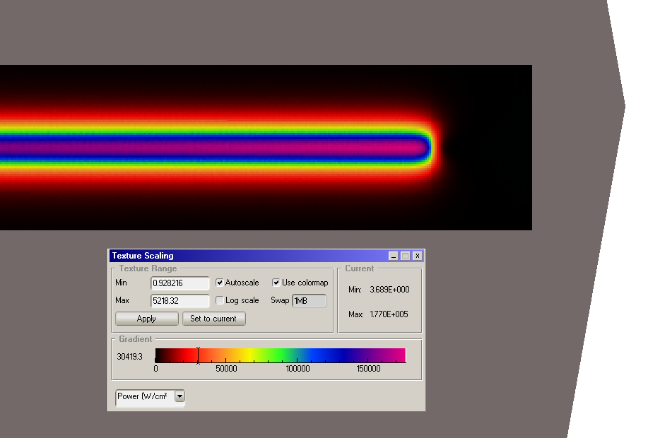

Figure 3.1.2: Zoom-in to SynRad power density profile

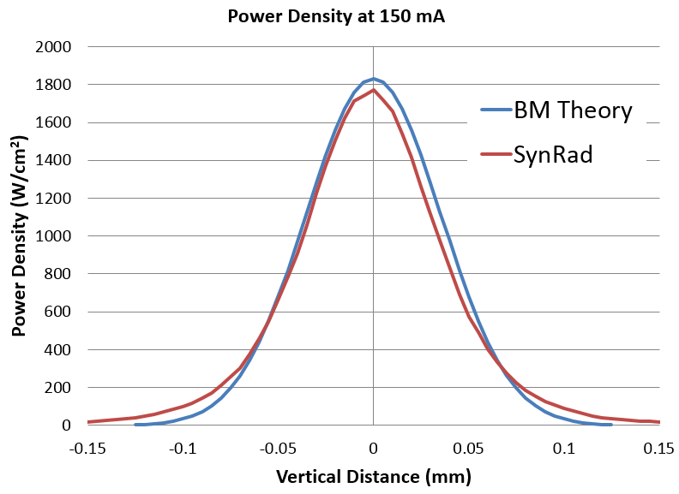

Figure 3.1.3 Peak power density profile along vertical stripe of beam

|  |  |  |  |  |  |  |
| --- | --- | --- | --- | --- | --- | --- |
| Facility | Beam energy | Beam current | Magnetic field | Ring radius | Fan width | Distance from source |
| APS | 7 GeV | 150 mA | 0.6 T | 38.961 m | 5.15 mrads | 0.8 m |

Table 3.1.1 Source parameters

|  |  |  |  |
| --- | --- | --- | --- |
|  | Theory | SynRad | % diff |
| Total Power (W) | 670 | 670 | 0.0% |
| Peak power density (W/mm2) | 1830 | 1773 | 3.1% |

Table 3.1.2 Comparison of SynRad vs theory

## Benchmarking to vacuum systems

TBD

## Benchmarking to comparable programs

### SynRad3D (Cornell)

SynRad3D is a program created at Cornell for generating synchrotron radiation distributions. The program has no relation to the CERN code (despite the close names) and is a good program for comparison.

An example problem is created that can be similarly constructed in both programs in order to compare program output. The example simply projects photons from a dipole source onto the walls of a 22mm ID round chamber. The dipole source is the M1 magnet from version 6 of the APS-U MBA lattice [2] and the chamber length and location represent the A multiplet section without any absorbers. The goal is to compare how photons are deposited and reflected both along the length of the chamber and azimuthally around the circular chamber, see Figure 3.3.1. In the left image within the figure, measurements are only made along the 2.94 m long length of the chamber highlighted in red. The square blocks in the image

Photons are reflected in both chambers based on an assigned surface roughness ratio and material reflectivity table. The roughness ratio is the ratio of the average roughness divided by the correlation length.

A custom reflectivity table was created for Al2O3, see Figure 3.3.2, which can be used equivalently between both programs. The table was created by collecting data for the percentage of photons reflected per photon energy and incidence angle from the LBNL Center for X-Ray Optics [3] [4]. Data was collected for photon energies ranging from 35 to 30000 eV. The CERN code references the low or high energy value for photons generated outside of this range. The angles range from zero (shallow incidence) to 90 degrees (normal incidence). The table shows that the reflectivity ranges from almost 100% reflection at shallow incidence to almost no reflection at normal incidence. Lower energy photons are also more likely to reflect than higher energy photons.

The distributions of photons along the length of the chamber are compared in Figure 3.3.3 for a variety of surface roughnesses. The azimuthal distribution of the photons are compared in Figure 3.3.4 for a variety of surface roughnesses.

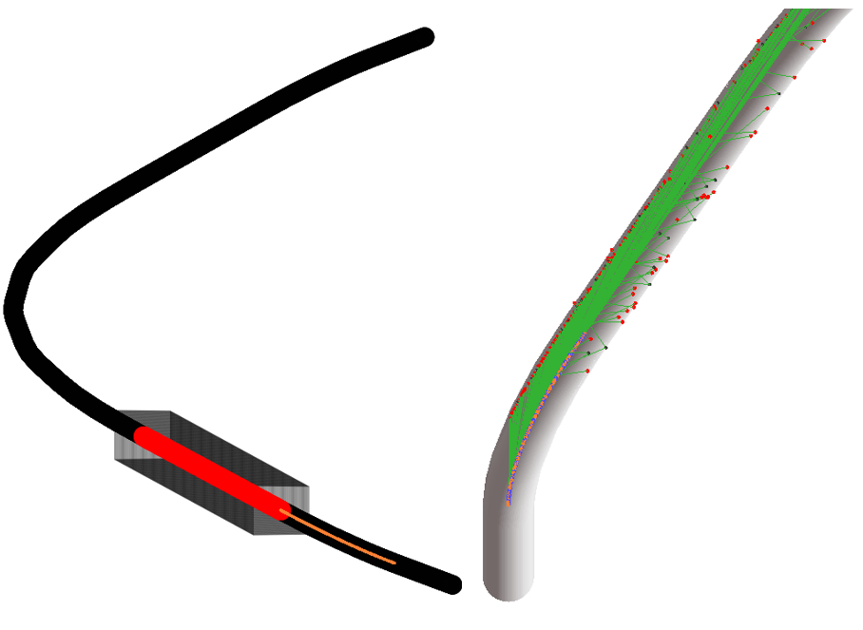

Figure 3.3.1 SynRad (CERN) model of first multiplet region of MBA lattice

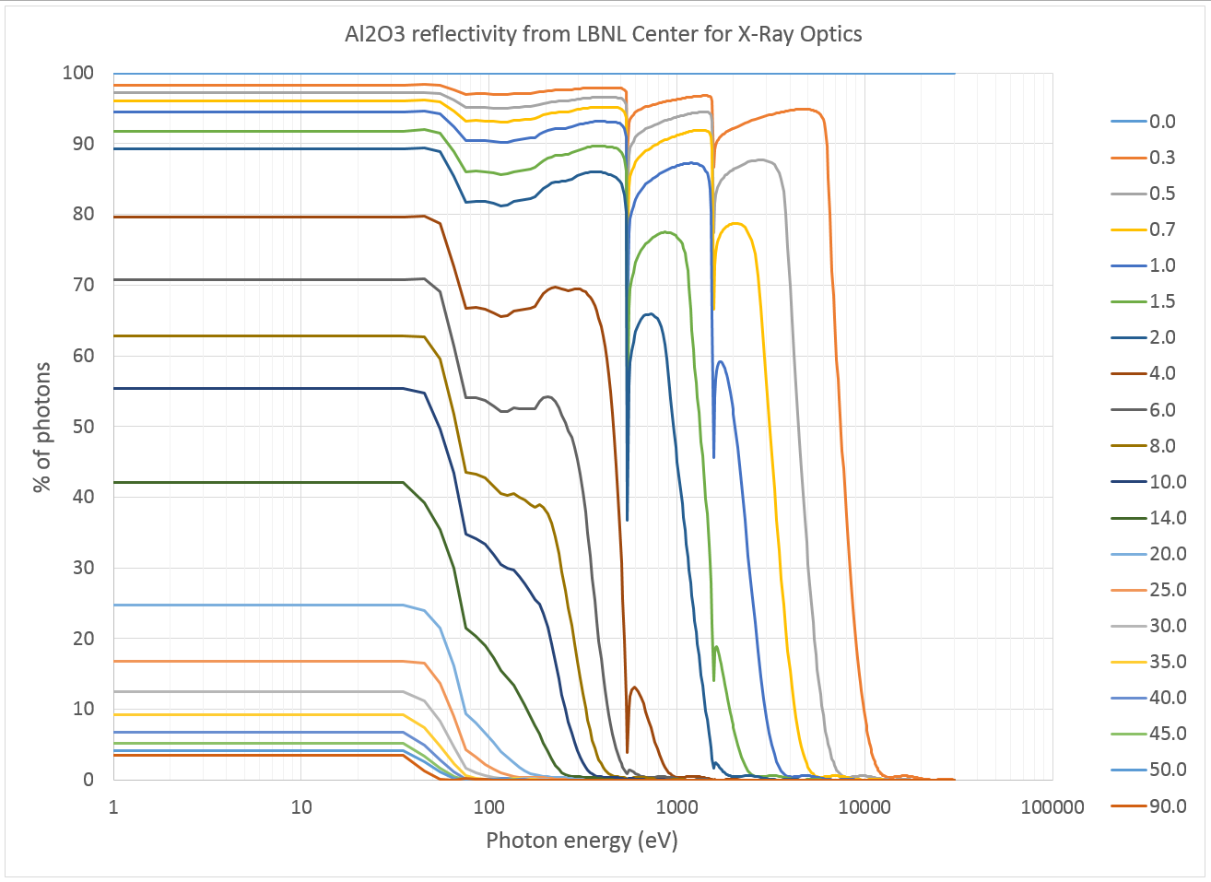

Figure 3.3.2 Al2O3 reflectivity vs photon energy and angle from LBNL Center for X-Ray Optics

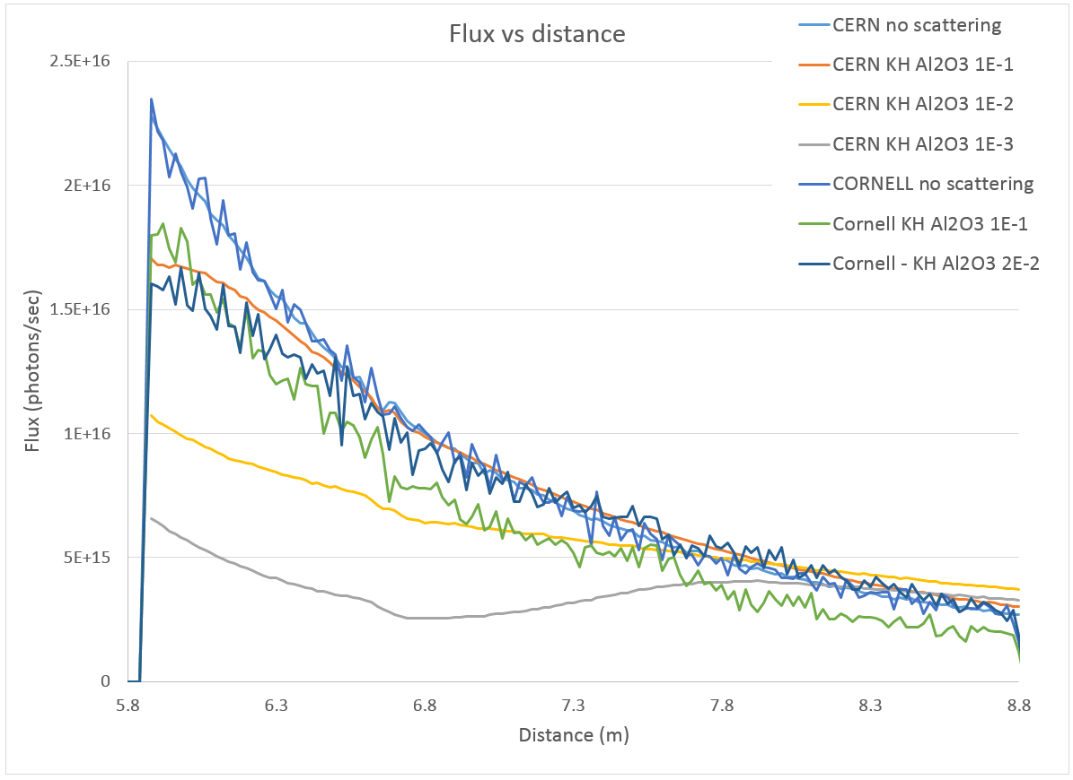

Figure 3.3.3 Comparison of distribution of photon flux along the length of chamber walls

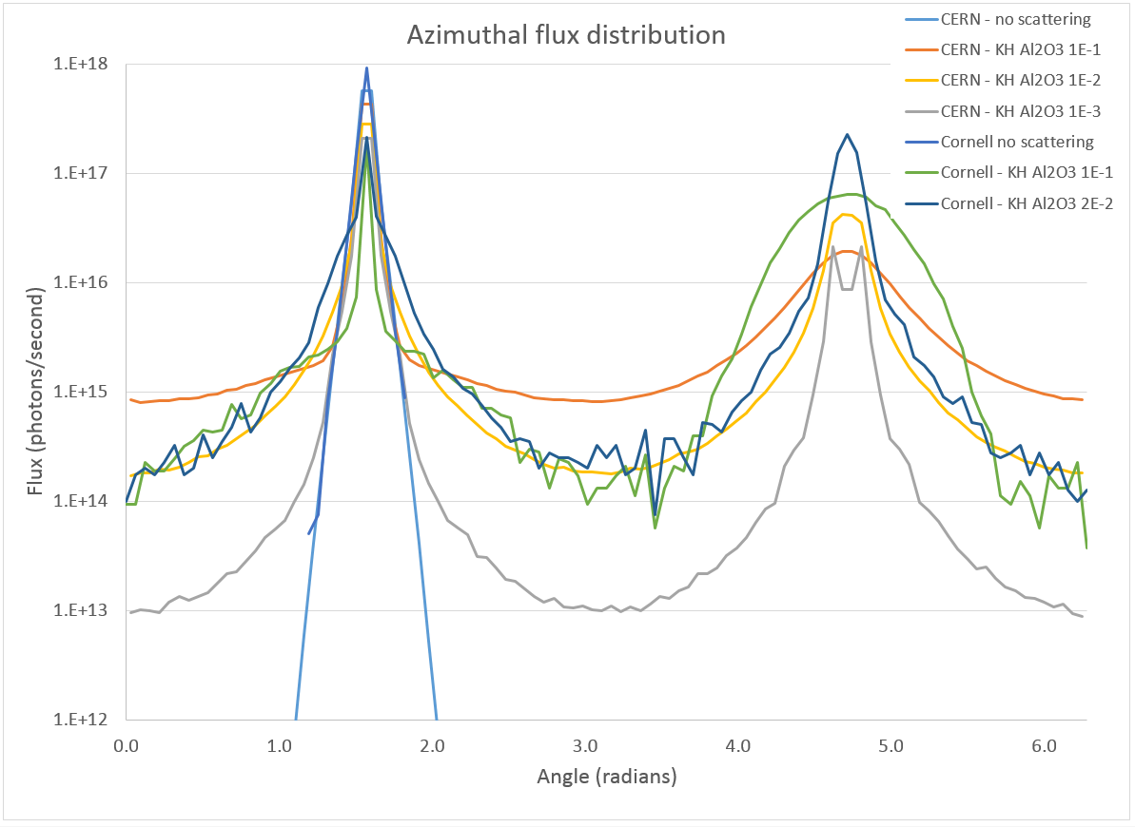

Figure 3.3.4 Comparison of azimuthal distribution of photon flux on chamber walls

# Coupled Simulations

Coupled simulations are performed by translating SynRad computed photon flux density maps into photon stimulated desorption outgassing in MolFlow+. The translation is determined by using PSD measurements for various vacuum materials as a map from photon flux accumulation to PSD outgassing.

## Benchmarking to theory

TBD

### VacCalc

TBD

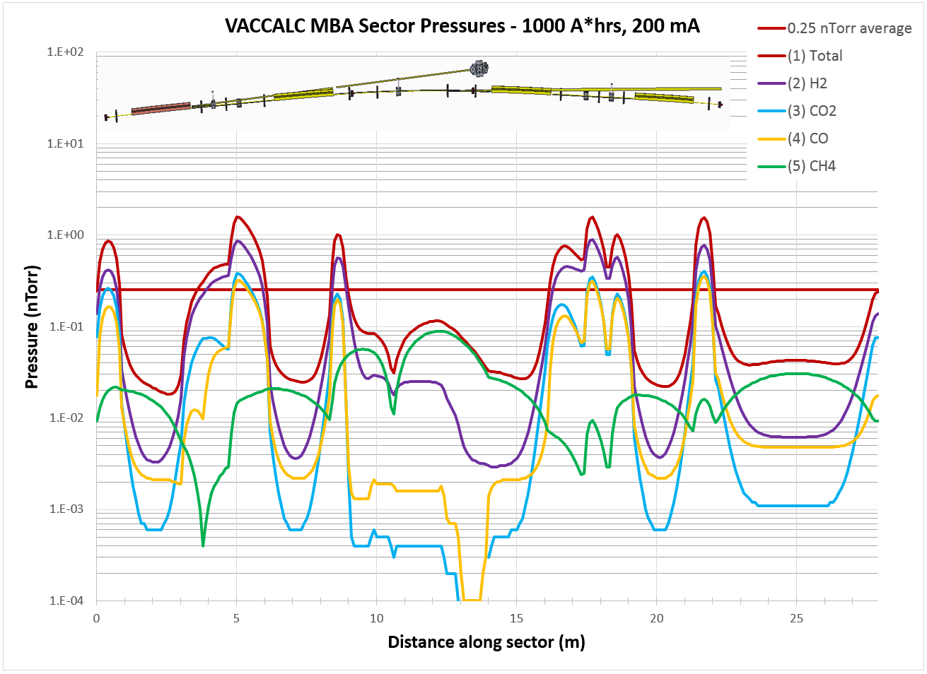

Figure 4.1.1 VACCALC pressures for the APS-U storage ring at 1000 A*hrs. conditioning  
(with Foerster aluminum PSD yields)

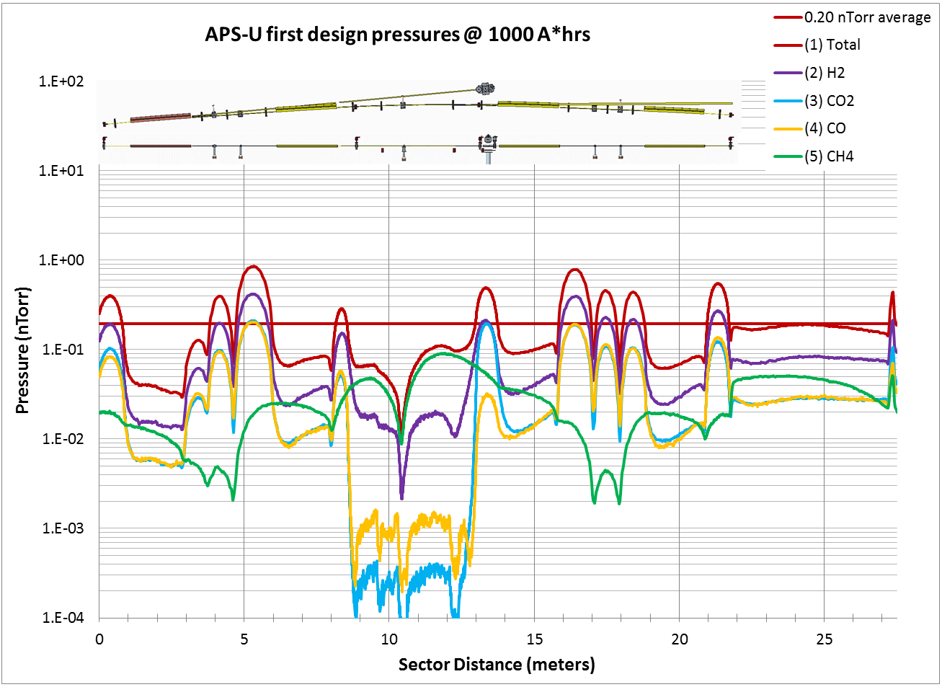

Figure 4.1.2 MolFlow+ pressures for the APS-U storage ring at 1000 A*hrs. conditioning  
(with Foerster aluminum PSD yields)

## Benchmarking to vacuum systems

Efforts have been made to benchmark the coupled simulation output with pressures from existing vacuum system within Argonne National Laboratory and the Advanced Photon Source (APS).

### APS storage ring vacuum system

Figure 4.2.1 shows a top level CAD view of one sector of the APS storage ring. Pieces of this CAD model were brought directly into SolidWorks as sketches in order to accurately locate and model complicated aspects of the system such as the absorber bodies.

Figure 4.2.2 shows the 3D Solidworks model of the vacuum system for one sector of the APS storage ring. The solid model actually represents the empty volume under vacuum within the vacuum system. Bodies are cut out of the volume to represent absorbers and beam screens.

Table 4.2.1 compares heat load distributions from SynRad to the AutoCAD ray trace.

Figure 4.2.3 shows a SynRad model of the APS storage ring in progress with the green lines representing the synchrotron radiation fan created by the dipole sources.

Figure 4.2.4 shows the flux density distribution in log scale on meshed surfaces.

Figure 4.2.5 shows a MolFlow+ model of one sector of the APS storage ring. Pumping surfaces are highlighted in red and represent NEG strips and ion pumps.

Figure 4.2.6 shows pressure profiles calculated in MolFlow+ for the system at a conditioning time of 10 A*hrs at 100 mA full beam current.

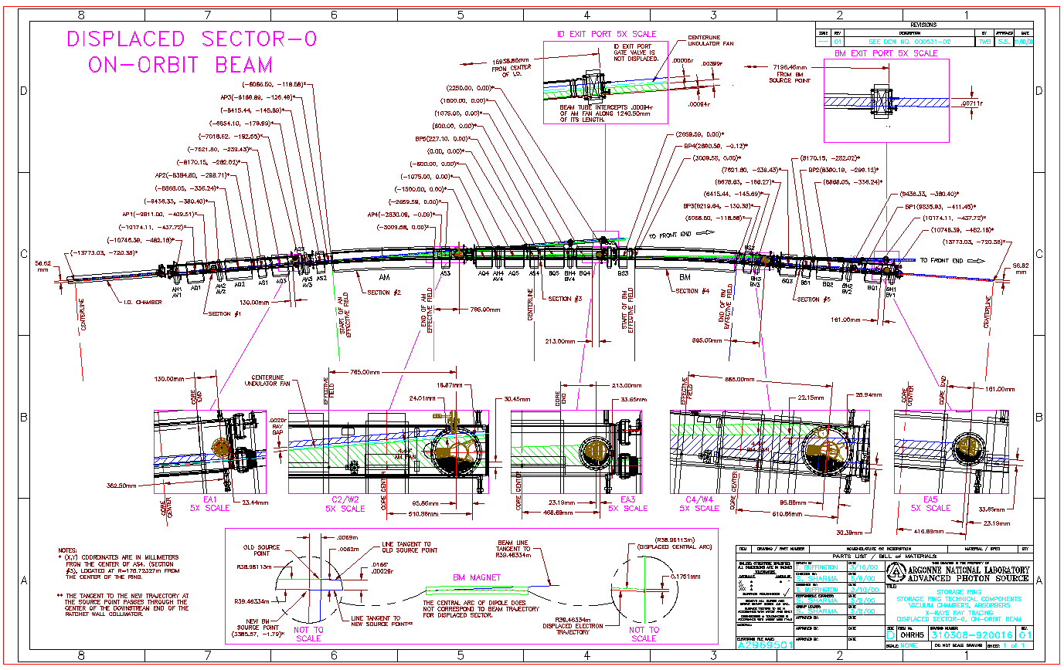

Figure 4.2.1 APS storage ring ray trace in AutoCAD (APS Dwg. #310308-920016)

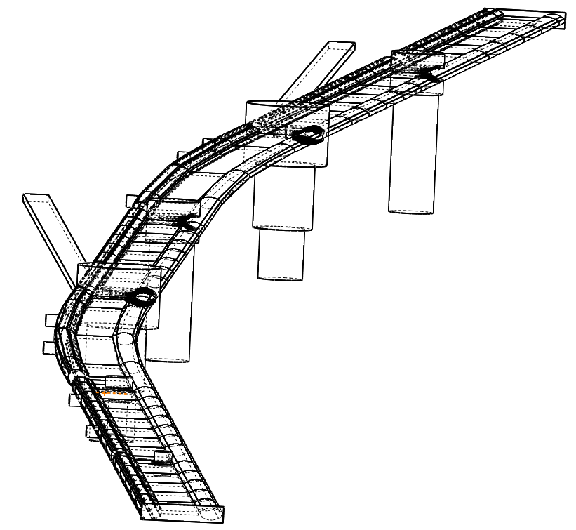

Figure 4.2.2 Solidworks model for SynRad/MolFlow+ of one sector of the APS storage ring

|  |  |  |  |
| --- | --- | --- | --- |
| Absorber | 2D RAY TRACE (W) | SYNRAD  (W) | Difference (W) |
| FIRST BOOT | 392 | 355 | 37 |
| EA1 | 84 | 52 | 32 |
| W2 | 137 | 137 | 0 |
| STRAIGHT | 347 | 420 | -73 |
| STRAIGHT WALL | 80 | 163 | -83 |
| C2 | 4245 | 4394 | -151 |
| EA3 | 1418 | 1321 | 97 |
| WALL | 222 | 270 | -48 |
| W4 | 845 | 892 | -47 |
| STRAIGHT | 610 | 607 | 3 |
| C4 | 3666 | 3842 | -176 |
| EA5 | 1256 | 1168 | 88 |
| total | 13300 | 13621 | -321 |

Table 4.2.1 Comparison of heat load distributions between SynRad and Ray Trace

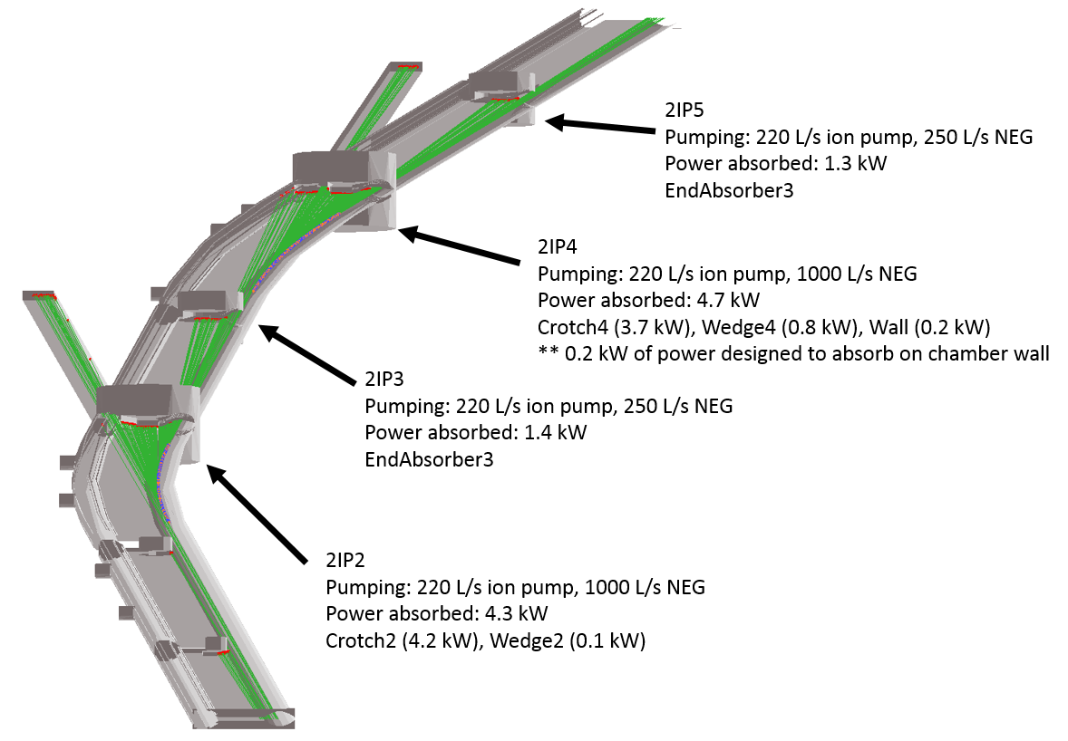

Figure 4.2.3 Heat load distribution in SynRad model of APS storage ring  
with pumping speeds and total heat loads noted at major absorbers

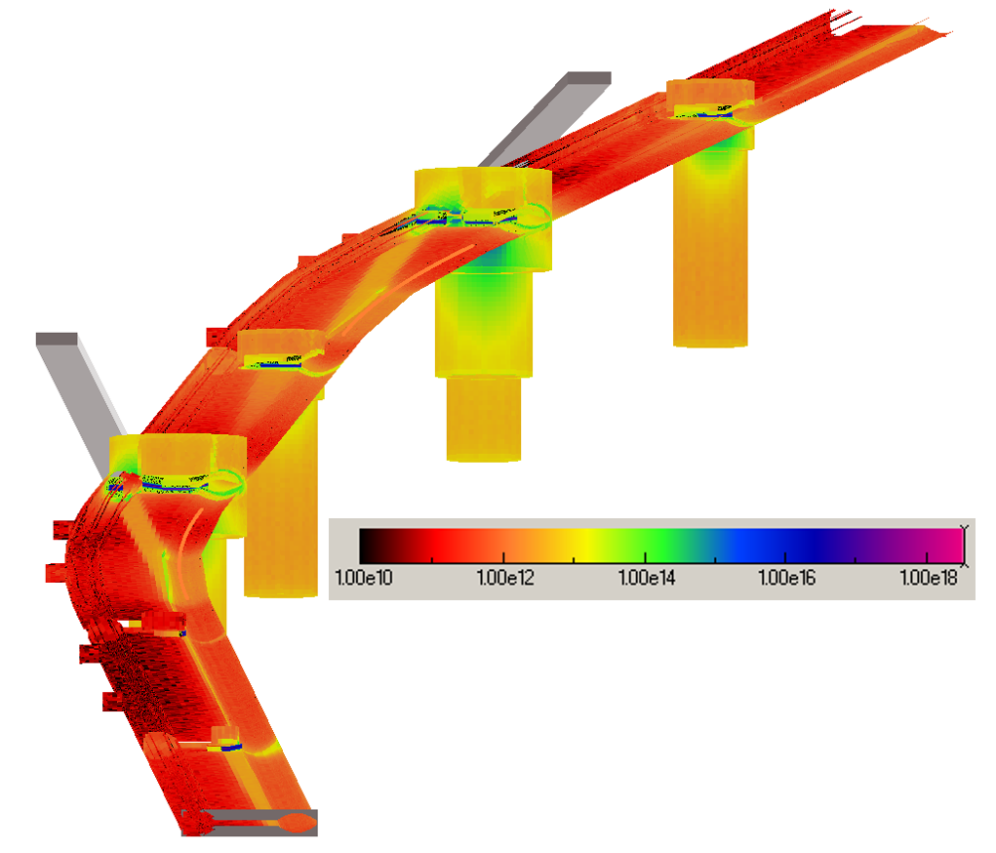

Figure 4.2.4 SynRad flux density distribution (photons/cm2/s, log scale)  
on vacuum surfaces within model of an APS storage ring sector

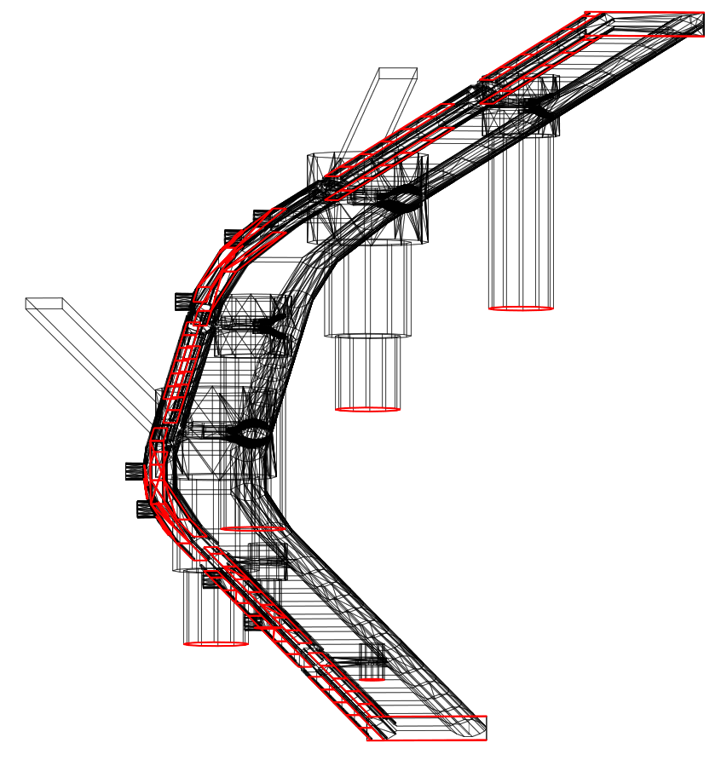

Figure 4.2.5 MolFlow+ model of APS storage ring sector with pumping surfaces highlighted in red

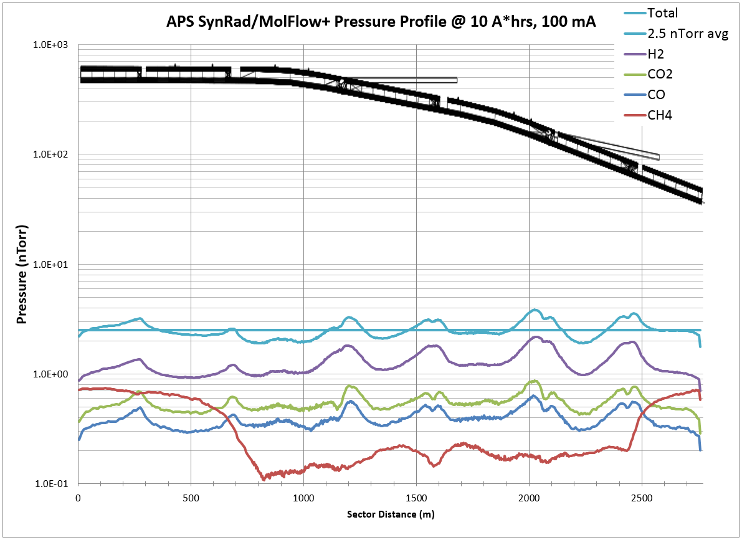

Figure 4.2.6 MolFlow+ pressure profile for one sector of the APS storage ring at 10 A*hrs conditioning

### PAR Vacuum System

Figure 4.2.7 shows a top view of the PAR vacuum system from an AutoCAD layout. Pieces from this CAD drawing are imported directly into SolidWorks as sketches in order to build an accurate full scale 3D model of the vacuum system.

Figure 4.2.8 shows a full scale 3D model of the PAR vacuum system in SolidWorks.

Figure 4.2.9 shows the SynRad flux density map in log scale on meshed surfaces of the PAR vacuum system model.

Figure 4.2.10 shows the MolFlow+ model of the PAR vacuum system. Pumping surfaces are highlighted in red and represent the ion pumps.

Figure 4.2.11 shows pressure profiles computed in MolFlow+.

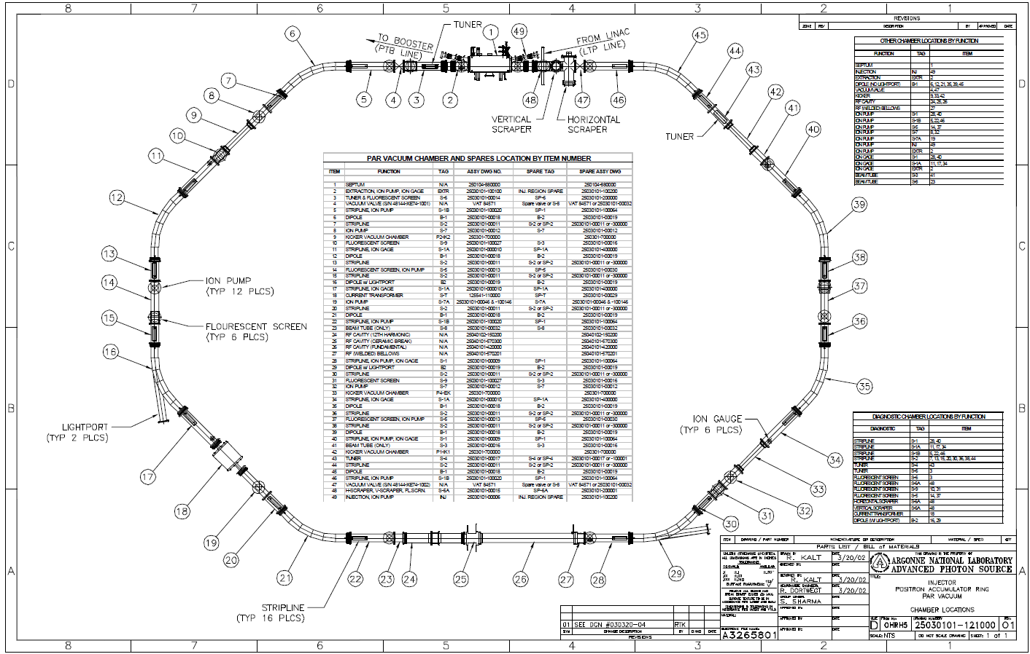

Figure 4.2.7 CAD layout of the PAR vacuum system (APS Dwg. #25030101-121000)

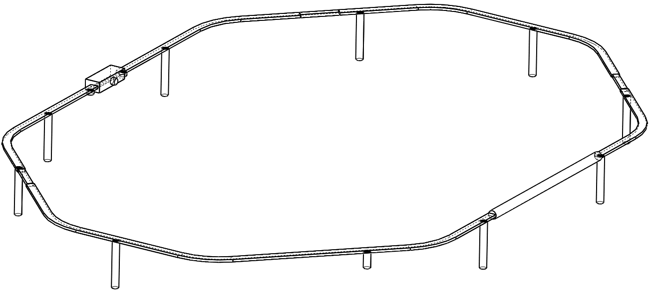

Figure 4.2.8 SolidWorks CAD model for SynRad/MolFlow+ of the PAR vacuum system

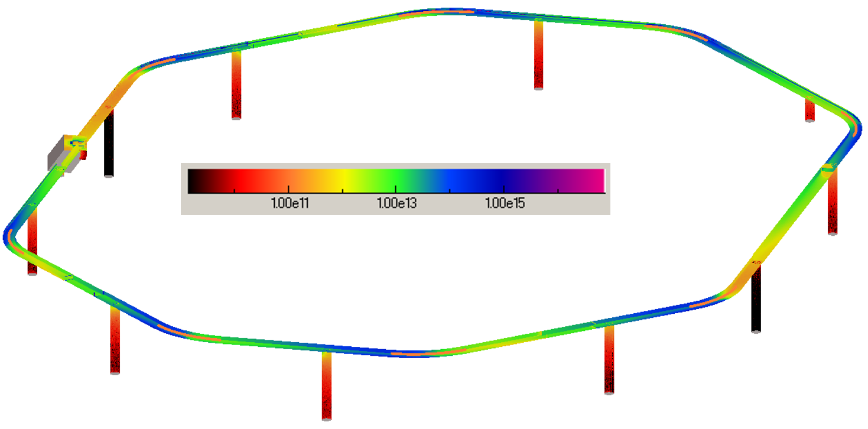

Figure 4.2.9 SynRad flux density distribution (photons/cm2/s, log scale) for PAR vacuum model

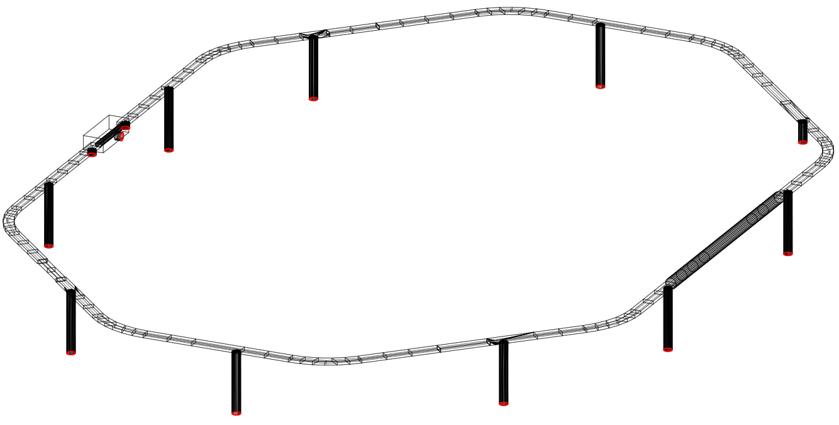

Figure 4.2.10 MolFlow+ model of PAR vacuum system (pumping surfaces highlighted in red)

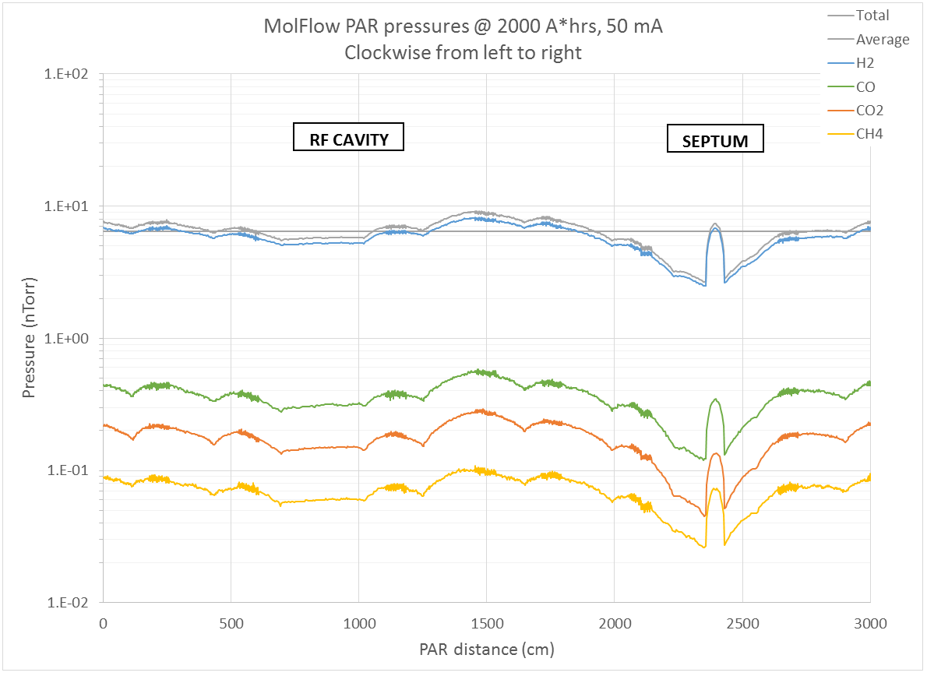

Figure 4.2.11 MolFlow+ pressure profile for PAR vacuum system

### Aluminum PSD study

A study was performed to compare various published photon stimulated desorption (PSD) measurements performed on aluminum chambers. PSD measurements have been published for aluminum chambers manufactured for a variety of chamber geometries including the LEP extrusion [5], the NSLS extrusion [6], an elliptical tube [7], and the APS extrusion [8]. Table 4.2.2 compares basic aspects of the geometries for the four measured chambers. Table 4.2.3 compares relevant experimental factors for the four experiments. Figure 4.2.12 highlights extrusion cross sections for three of the four chambers.

|  |  |  |  |  |  |
| --- | --- | --- | --- | --- | --- |
|  | Chamber shape | Paper author | Height (cm) | Width (cm) | Surface area (cm2/m) |
| 1 | Ellipse [7] | Mathewson | 7.0 | 13.1 | 3230 |
| 2 | NSLS extrusion [6] | Kobari | 4.0 | 13.5 | 3840 |
| 3 | LEP extrusion [5] | Grobner | 9.3 | 18.0 | 6450 |
| 4 | APS extrusion [8] | Foerster | 5.6 | 28.1 | 7380 |

Table 4.2.2 Comparison of published PSD measurements on aluminum vacuum chambers  
sorted by surface area of chamber

|  |  |  |  |  |  |  |  |  |
| --- | --- | --- | --- | --- | --- | --- | --- | --- |
|  | Machine (beamline) | Beam energy (GeV) | Beam current (mA) | Source strength (T) | Chamber angle (mrad) | Chamber length (m) | Exposed length (m) | Photon flux on chamber (pho/s) |
| 1 | DCI | 1.72 | 180 | 1.525 | 11 | 3.60 | 2.98 | 1.51E17 |
| 2 | VUV (U10B) | 0.75 | 300 | 1.203 | 8.7 | 3.00 | 2.61 | 7.41E16 |
| 3 | DCI | 1.72 | 180 | 1.499 | 11 | 3.60 | 3.12 | 1.55E17 |
| 4 | NSLS (X28A) | 2.50 | 500 | 1.337 | 21 | 2.34 | 2.34 | 5.53E17 |

Table 4.2.3 Comparison of relevant experimental factors for various PSD measurements  
(sorted by numbering from Table 4.2.2)

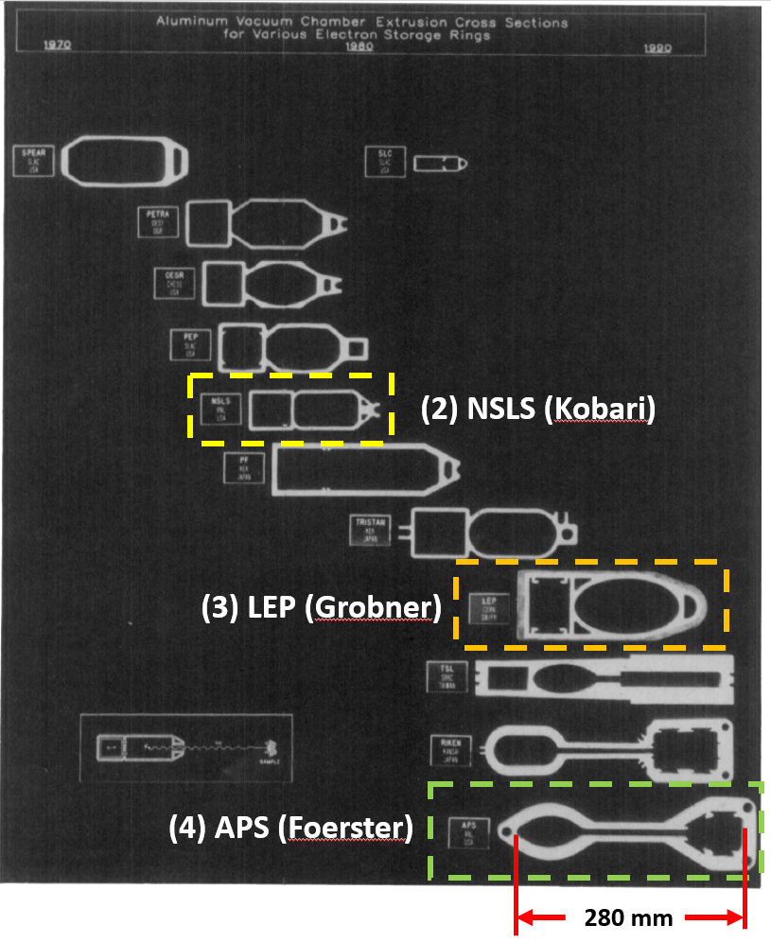

Figure 4.2.12 Comparison of three of the four aluminum chamber cross sections  
with published PSD measurements

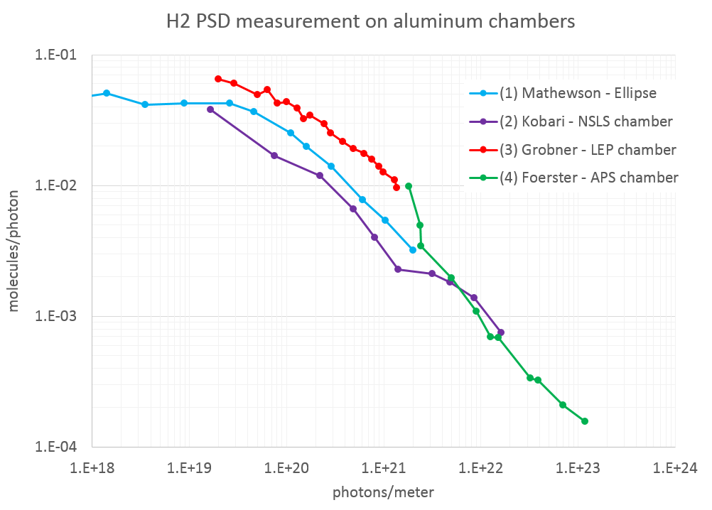

Figure 4.2.13 Comparison of four published H2 PSD yields measured on various aluminum chambers

For VacCalc, a linear function on a log-log map is approximated, as shown in Figure 4.2.14, to capture the slope of the PSD curve. This function predicts the gas load as a function of the accumulated photons as determined by a ray trace and is used to predict the dynamic PSD outgassing for use in a VACCALC simulation.

For MolFlow+, the four experiments must first be recreated in SynRad using the relevant parameters from Table 4.2.3, and details of the ray trace as shown in Figure 4.2.15, and the chamber geometries shown in Figure 4.2.16. An example of a SynRad simulation of a ray trace which includes photon scattering is shown in Figure 4.2.17. Figure 4.2.18 highlights the flux density distributions calculated and shown in log scale.

Next, calibrated maps must be created for each experiment which represents the conversion of the experimental x-axis units from linear photon accumulation in units of photons/meter to area accumulation, as computed in SynRad, with units of photons/cm2. The maps are calibrated in an iterative process where the approximated functions from Figure 4.2.14 are used to map the SynRad flux densities. The functions are then calibrated until the mapped outgassing values in MolFlow+ match the original experimental data for multiple conditioning time points.

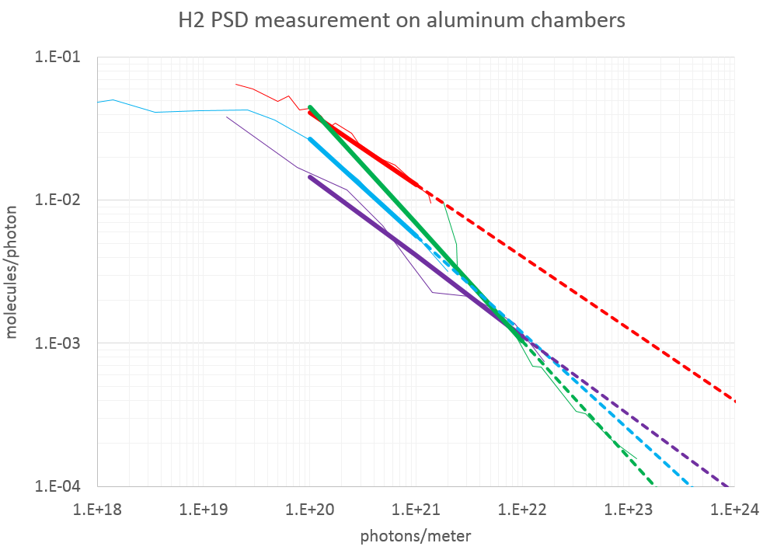

Figure 4.2.14 Cleanup slopes approximated from PSD measurement data

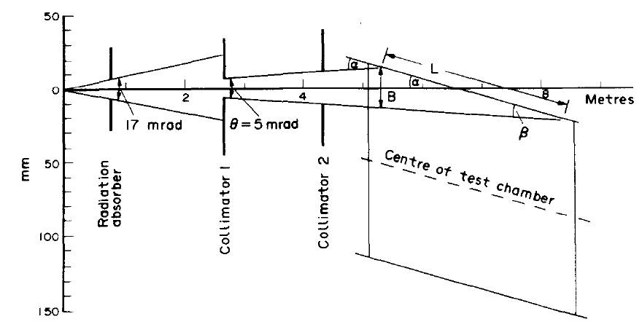

Figure 4.2.15 Typical ray trace for design of a laboratory PSD measurement

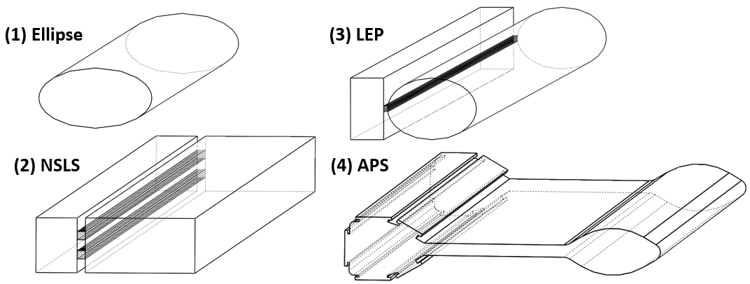

Figure 4.2.16 CAD models of the four chamber geometries for use in MolFlow+

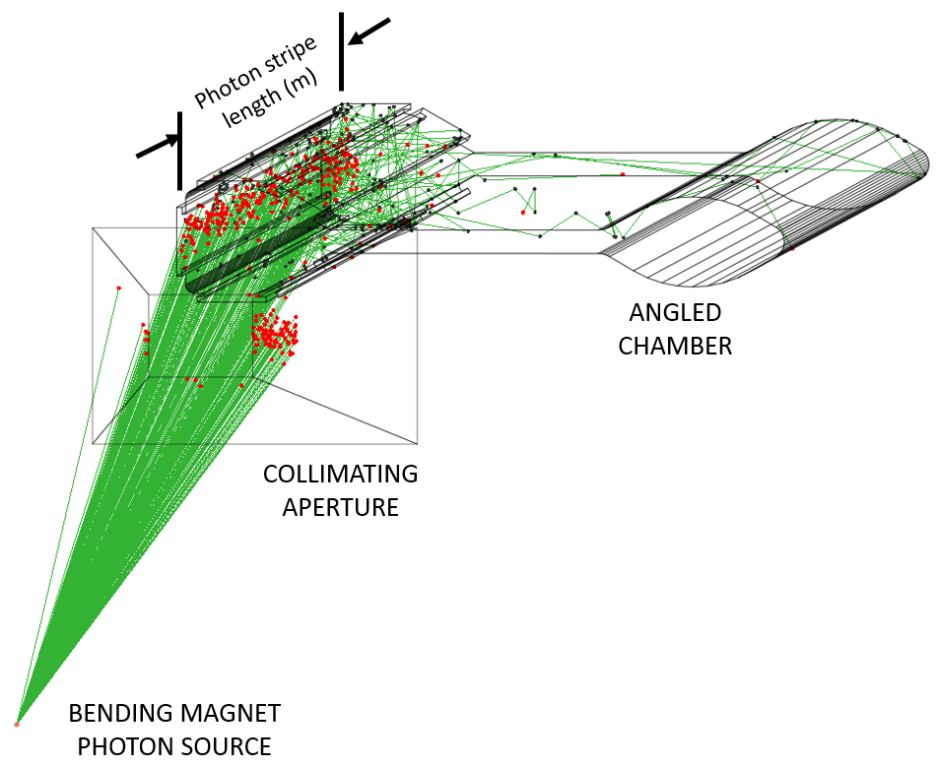

Figure 4.2.17 Ray trace from a PSD measurement recreated in SynRad with photon scattering

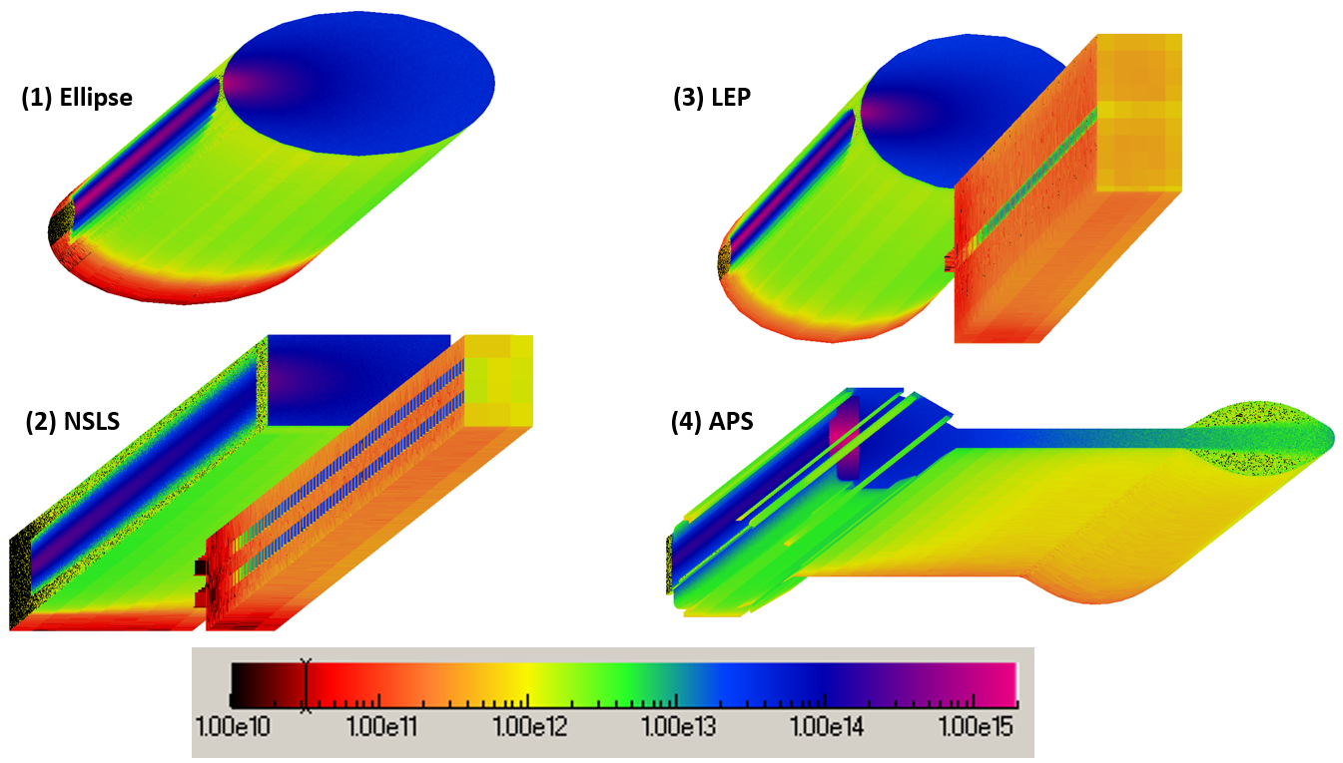

Figure 4.2.18 Photon flux densities (photons/cm2/s) in log scale determined from SynRad simulations  
for the four aluminum chamber geometries

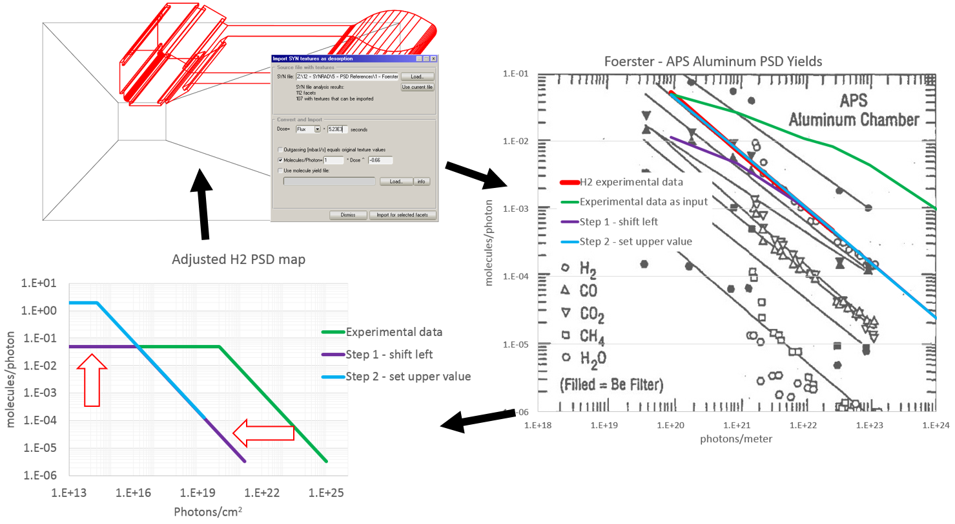

Figure 4.2.19 Diagram of iterative process for calibrating PSD yields for use in MolFlow+  
where the approximated PSD functions are used to map the fluxes from Figure 4.2.18 to outgassing in MolFlow+. The functions are adjusted until the predicted outgassing matches the original data

After the MolFlow+ calibration, vacuum simulations are performed for a model of the APS-U storage ring sector are performed with equal pumping assumptions and near equal geometric assumptions. It should be noted that MolFlow+ uses 3D geometry of the vacuum surfaces to compute conductance where VACCALC requires a coded input of the conductance value. The conductances for the various APS-U chamber cross sections have been checked carefully to ensure as close of a match as possible.

Table 4.2.4 compares the average total pressures computed with both VACCALC and MolFlow+ for the four chambers. Total pressure indicates the sum of pressures individually computed for the assumed four major gases: H2, CO2, CO, and CH4. Figure 4.2.20 compares the total pressure profiles computed in VACCALC for the four chambers. Figure 4.2.21 compares the total pressure profiles computed in MolFlow+.

|  |  |  |  |
| --- | --- | --- | --- |
|  | Author (chamber) | VACCALC | MolFlow+ |
| 1 | Mathewson (ellipse) | 0.61 | 0.73 |
| 2 | Kobari (NSLS) | 1.60 | 1.43 |
| 3 | Grobner (LEP) | 4.94 | 3.64 |
| 4 | Foerster (APS) | 0.23 | 0.20 |

Table 4.2.4 Average total pressures computed using VACCALC and MolFlow+  
(sorted from smallest to largest chamber surface area)

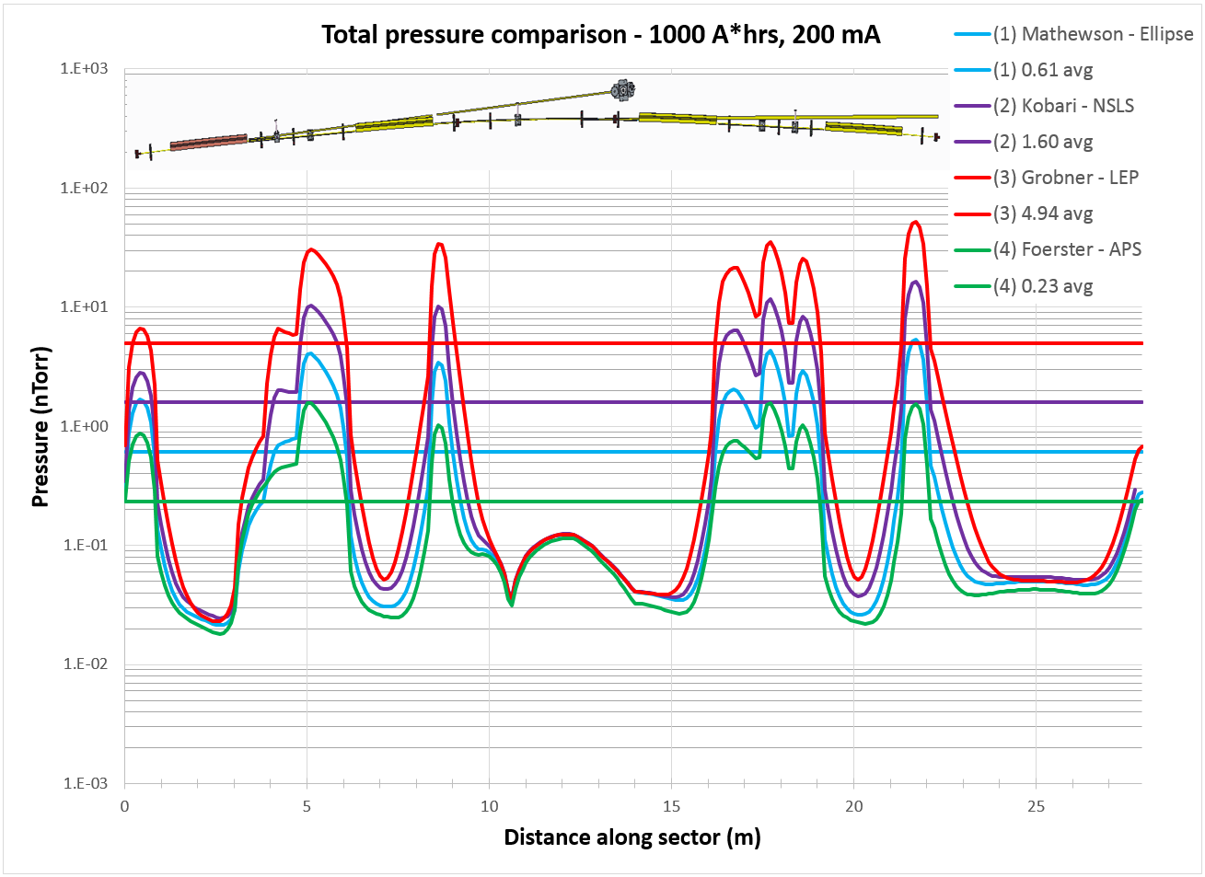

Figure 4.2.20 Comparison of total pressures computed using VACCALC

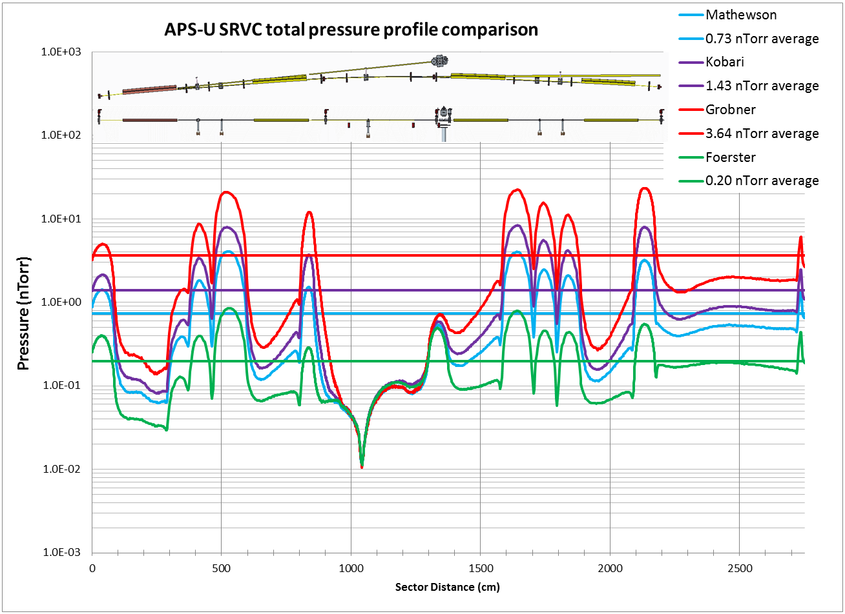

Figure 4.2.21 Comparison of total pressures computing using MolFlow+

The study reveals that a range of PSD yields have been measured for aluminum chambers and that numerous factors likely influence the measurement including the chamber geometry and bakeout conditions.

# References

|  |  |
| --- | --- |
| [1] | R. Kersevan and M. Ady, "MolFlow+ - A Monte-Carlo Simulator Package developed at CERN," CERN VSC Group, 2015. [Online]. Available: http://test-molflow.web.cern.ch/. |
| [2] | M. Borland, "Lattice File Version 6," 2014. [Online]. Available: https://apsshare.aps.anl.gov/apsu/MBAWorkingGroup/Shared%20Documents/Beam%20Physics/Version6Lattice.xlsx. |
| [3] | E. Gullkson, "X-Ray Interactions with Matter," LBNL Center for X-ray Optics, 2010. [Online]. Available: http://henke.lbl.gov/optical_constants/. [Accessed August 2015]. |
| [4] | B. Henke, E. Gullikson and J. Davis, "X-Ray Interactions: Photoabsorption, Scattering, Transmission, and Reflection at E=50 – 30,000 eV, Z = 1-92," *Atomic Data and Nuclear Data Tables,* vol. 54, no. 2, pp. 181-342, 1993. |
| [5] | O. Grobner, A. Mathewson, H. Stori and P. Strubin, "Studies of photon induced gas desorption using synchrotron radiation," *Vacuum,* vol. 33, no. 7, pp. 397-406, 1983. |
| [6] | T. Kobari and H. Halama, "Photon stimulated desorption from a vacuum chamber at the National Synchrotron Light Source," *Journal of Vacuum Science & Technology A,* vol. 5, no. 4, pp. 2355-2358, 1987. |
| [7] | A. Mathewson, O. Grobner, P. Strubin, P. Marin and R. Souchet, "Comparison of synchrotron radiation induced gas desorption from Al, stainless steel, and Cu chambers," CERN, 1990. |
| [8] | C. Foerster, C. Lanni, J. Noonan and R. Rosenberg, "Photon stimulated desorption measurement of an extruded aluminum beam chamber for the Advanced Photon Source," *Journal of Vacuum Science & Technology,* vol. A, no. 14, p. 1273, 1996. |